Insight Feed
Data-Driven Intelligence and Market Analytics
Oct 9, 2026 · @Mohandas Ayikara

1. Executive summary and problem statement
CME can turn its raw order book data into predictive probabilities and analytics, delivered to market participants in near real time. Each boutique trading firm would avoid an estimated $2-3 million of build cost, and CME could add an illustrative $100 million of annual data revenue (assumptions in section 2.3).
The problem. Exchanges publish raw market data. They do not publish real-time, value-added metrics or predictive signals built from it, and no dataset provides probability or alpha signals. To use the data in trading and risk decisions, every firm must ingest the feed, rebuild the order book, calculate metrics, train models and keep the whole pipeline running. That is a large software and capital effort, and it is the main barrier to entry for smaller firms.
Our answer: the CME Insight Feed. For each instrument, every 50 or 200 milliseconds, subscribers receive:
- standard order book metrics, such as imbalance, spread and liquidity concentration;
- calibrated probabilities that the price moves up, stays flat or moves down, and that the spread widens, with a confidence score;
- a data-quality flag on every record, so firms know when not to trust a reading.
Why CME, why now. CME already supplies market data through Google Cloud, including real-time and delayed feeds and historical market depth back to 2014 through Analytics Hub (CME Group). The delivery rails, the data and the technology partner are in place.

1.1 The friction point
- No exchange-supplied analytics. Raw data is the only real-time product, so every analytic is built outside the exchange.
- Duplicated effort. Each firm rebuilds the same book reconstruction, features and models, and each ends up with slightly different definitions.
- High cost and long lead time. The team estimates $2-3 million for an average boutique shop to reach a first working signal (section 2.3).
- Unequal access. Large high-frequency firms can afford it. Smaller firms either go without or buy from vendors who sit between them and the exchange.
- Research that does not match production. Firms' backtests rarely line up exactly with what they see live.

1.2 Who is affected
Boutique and proprietary trading firms, market makers, banks and dealers, commercial hedgers, asset managers, and the brokers that serve retail clients, as well as CME itself, which is the source of the data but captures none of the analytics value.

2. Market impact and business value
Turning raw market data into signals costs an average boutique shop $2-3 million, and CME can capture that value as roughly $100 million of added annual data revenue. Both figures are team estimates, not forecasts. Section 2.3 shows how each is built, and the pilot is designed to test them.

2.1 Value for market participants
- Cost avoided: an average boutique shop saves $2-3 million of build and first-year running cost.
- Speed: a first working signal takes days of integration instead of months of engineering.
- Consistency: every firm uses the same exchange-defined measures, with clear provenance and the same time grid in history and live.
- Access: smaller firms get analytics that only the best-resourced firms could build before.
- Better risk and execution control: the spread-widening probability and confidence score support quote management, order timing and position sizing. Banks and commercial hedgers can use them to time hedges and watch intraday liquidity.

2.2 Value for CME
- New revenue: about $100 million a year.
- Higher in the value chain: CME moves from selling raw data to selling insight, which is harder for vendors to copy.
- Low incremental cost: the delivery channels, entitlements and data already exist, so each new subscriber adds little cost.
- Platform: the same pipeline extends to more instruments, faster channels and further analytics.
- Possible market-quality benefit: better-informed liquidity providers may quote with more confidence. This is a hypothesis to test, not an assumed outcome.

2.3 Assumptions behind the figures
The two tables below are illustrative team assumptions. They are not forecasts, and each line should be replaced with validated numbers from client interviews and the pilot.
Average boutique shop: year-one cost avoided
Cost line | Assumption | $ million
Team | 5-6 engineers and quants for 12-18 months | 1.5-2.0
Cloud compute, storage and data transport | Training, serving and history | 0.3-0.5
Monitoring, quality assurance and operations | First-year running cost | 0.2-0.3
Total |  | 2.0-2.8, about $2-3 million
CME: one illustrative path to $100 million a year
Segment | Firms | Average annual fee ($ thousand) | $ million
Proprietary firms and market makers | 100 | 500 | 50
Boutique and mid-size firms | 200 | 150 | 30
Banks, asset managers and commercial hedgers | 50 | 400 | 20
Total | 350 |  | 100
At the illustrative $150,000 fee, a boutique firm pays roughly one-thirteenth to one-twentieth of the $2-3 million it avoids in the first year.

2.4 Who benefits
Beneficiary | Benefit
Boutique and proprietary firms | Signals without a multi-million-dollar build
Market makers | Earlier warning of spread widening and one-sided flow
Banks and dealers | Better pricing and hedging of client flow, and intraday risk visibility
Commercial hedgers | Better timing and execution of hedges, usually through brokers or algorithms
Asset managers | Improved execution quality and intraday risk monitoring
Retail participants | Indirect benefit through brokers and platforms that use the feed
CME | New data revenue, deeper client relationships, differentiation from vendors

3. Proposed solution and novelty
The CME Insight Feed converts CME's real-time order book into metrics and predictive probabilities and sends them to clients in near real time. CME does not offer this today, and to the team's knowledge no other exchange does either.

3.1 Core solution and workflow
- Ingest the real-time market data feed from CME on Google Cloud.
- Rebuild the order book for each instrument and sample it at fixed 50 and 200 millisecond steps.
- Calculate metrics: imbalance, order flow, short-term volatility, liquidity concentration and the mix of recent order flow.
- Predict: AI/ML models turn the metrics and the recent order events into calibrated probabilities of an up, flat or down price move at 200 milliseconds and one second, and of the spread widening, plus a confidence score.
- Check quality: automated checks flag sequence gaps, stale and crossed books and bad values. The flag travels with every record.
- Deliver in near real time through streaming APIs and subscriptions, with history and replay through BigQuery sharing.
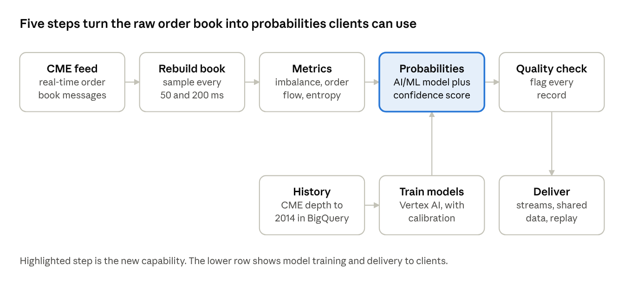
workflow · 5 live steps, plus training and delivery
The top row runs continuously on the live feed. The lower row shows where the model comes from and how results reach clients.
The probabilities come from a small transformer model trained on historical CME data and benchmarked against simpler models. If it does not beat them on held-out data, the product ships the simpler model's probabilities and the metrics, which are still the core of the offer.

3.2 Business mechanism
- Sell the signal, not the data volume. One model serves every subscriber, so the cost of building it is shared across the market instead of repeated by each firm.
- Three tiers. Core gives the standard metrics. Analytics adds the probabilities and confidence score. Research adds history, replay and evaluation tools.
- Familiar commercial model. Pricing can follow CME's existing cloud approach, which is on demand with no long-term commitment, alongside annual subscriptions.
- Pilot first. A 6-8 week pilot with design-partner firms from different segments, with a go or no-go gate on measurable value before any broad launch.

3.3 How this differs from today
Area | Today | With the CME Insight Feed
Real-time metrics from the exchange | None; each firm calculates its own | Standard measures published by CME
Predictive analytics | None from the exchange; built in-house or bought from vendors | Calibrated probabilities with a confidence score
Definitions | Differ from firm to firm | One exchange-defined set, with provenance
Data quality | Left to each client | Quality flag on every record, set by automated checks
Research to production | Backtests often differ from live behavior | Replay on the same time grid as live delivery
Access | Practical only for firms that can fund the build | Open to any subscriber
Delivery | Raw feed needs the client's own infrastructure | Cloud-native streaming and data sharing

3.4 Fit with the focus areas
Focus area | What the solution provides
Predictive liquidity modeling | Probability that the spread widens, plus liquidity concentration and order flow mix, refreshed every 50-200 milliseconds
Dynamic risk visibility | A confidence score and a quality flag on every record, and regime indicators from volatility and flow mix
Real-time insight from raw telemetry | One pipeline from raw order book to sampled snapshots, metrics and probabilities
New ways to commercialize and deliver data worldwide | A tiered insight product delivered over Google Cloud by streaming and by data sharing

4. Technical architecture, GCP and data strategy
The architecture has three parts on Google Cloud: a hot path that turns the live feed into probabilities within a fraction of a second, a cold path that trains and checks the models on history, and a control plane for entitlements and operations. The hot path runs on GKE, and the cold path runs on BigQuery, Dataflow and Vertex AI.
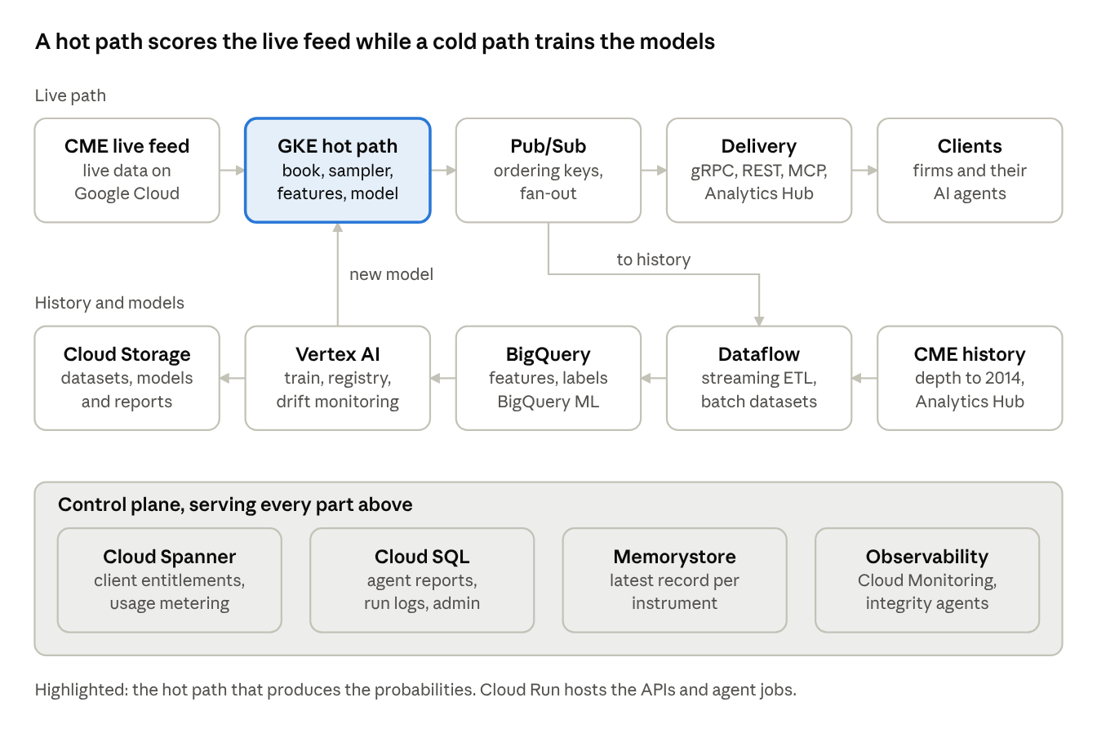
architecture · hot path, cold path and control plane
The top row is the live path from CME's feed to clients. The middle row builds and checks the models from history, and the band underneath holds entitlements, metadata and monitoring.

4.1 Google Cloud services and components
A. Data and AI/ML
Service | Role
BigQuery | Warehouse for sampled snapshots, features, labels and evaluation results. CME's historical market depth, back to 2014, is available through Analytics Hub, so training data needs no separate transfer. BigQuery ML provides the benchmark models (logistic regression and boosted trees)
Vertex AI Training and Pipelines | Trains the transformer model on GPUs and runs the retraining pipeline: dataset build, training, calibration, and evaluation against the benchmarks
Vertex AI Model Registry and Model Monitoring | Versions every model, supports shadow and canary releases and rollback, and watches for input and prediction drift
Cloud Storage | Parquet datasets, model artifacts and evaluation reports
Training data flows from the historical depth in BigQuery, through a batch Dataflow job that rebuilds the book and samples it, into feature tables, then into Vertex AI training and the model registry. Splits are chronological with a gap at each boundary, so no future information reaches training.
B. Streaming and compute
Service | Role
GKE | The hot path: stateful services, one shard per instrument group, for book reconstruction, the 50 and 200 millisecond sampler, feature calculation and model inference. Also hosts the low-latency streaming gateway. CPU and GPU node pools; models load from the registry
Pub/Sub | Fan-out of output records by product group, with ordering keys per instrument, dead-letter topics for failed messages, and subscriptions for clients and internal consumers
Dataflow | Streaming pipeline from Pub/Sub to BigQuery for history and audit, windowed quality metrics, and handling of late data. Batch jobs build training datasets
Cloud Run | Stateless microservices: the REST and replay API, entitlement checks, the AI-agent server, the admin backend, and scheduled jobs for the integrity and evaluation agents
Event processing: each market data message updates the book of its instrument in sequence order. At each grid boundary the sampler emits a record, the model scores it, and the record is published once to Pub/Sub and streamed to premium clients.
C. Storage and databases
Service | Role
Cloud Spanner | Client registry, entitlements, subscriptions and usage metering, plus the record of which model version serves each instrument. A multi-region configuration keeps permissions consistent for clients worldwide
Cloud SQL (PostgreSQL) | Operational metadata: integrity and evaluation reports, run logs and admin portal data, with regional high availability
BigQuery and Cloud Storage | System of record for history and model artifacts (group A)
Memorystore (Redis) | Latest record per instrument for fast snapshot requests
D. External and customer AI protocols
Interface | Role
gRPC with Protobuf | Primary low-latency stream, with versioned schemas
WebSocket (JSON) and Pub/Sub subscriptions | Easier integration for firms that do not use gRPC
Analytics Hub | Historical and replay data shared as BigQuery listings, the route CME already uses for market depth
REST with an OpenAPI description | Snapshot and history queries; the machine-readable description lets AI tools call the API directly
MCP server on Cloud Run | Lets a customer's AI agents call tools such as latest probabilities, history query and quality-flag explanation, under the same entitlements
Agent2Agent (A2A) | Optional interface for agent-to-agent integration with customers' AI platforms
These interfaces are our reading of "external and customer AI protocols" (see section 6).

4.2 Scalability, low latency and resilience
The design keeps the latency-critical work on a small stateful hot path, scales it by sharding instruments, and makes every failure visible in the data through a quality flag. The latency and recovery figures below are design targets to be proven in load and failover tests, not measured results.
Low latency
- Two delivery paths. The premium 50 millisecond stream goes straight from the GKE hot path over gRPC. The 200 millisecond channel and general subscriptions go through Pub/Sub.
- Targets: a record reaches a direct-stream client within 250 milliseconds of its grid time, and a Pub/Sub subscriber within one second.
- In-memory hot path. No database call per record: entitlements are cached, and all instruments in a shard are scored in one batched model call per grid step.
- Placement. Run in the Google Cloud regions where CME already delivers market data, to cut network hops.
Scale and peak concurrency
- Sharding. Instruments are split into groups, each handled by an independent shard, so capacity grows by adding shards.
- Autoscaling. Kubernetes scales on message rate, with extra replicas started before scheduled peaks such as market open and economic releases. Pub/Sub and Cloud Run scale automatically for fan-out and API load.
- Protection. Per-client quotas and rate limits stop one client from slowing the others.
- Load shedding. In an extreme burst, the pipeline keeps the book exact and the basic metrics flowing, and falls back to the last probabilities marked stale rather than delaying everything.
- Capacity tests. Replay the busiest historical days from BigQuery at multiples of their real rate.
Failover
- Warm standby. A second copy in another zone reads the same feed. Because the book is rebuilt deterministically from sequence numbers, both copies stay identical, and a leader election promotes the standby within seconds (target).
- Gap recovery. The book is rebuilt from the feed's snapshot messages. Samples inside the gap are flagged invalid until recovery.
- Disaster recovery. A second region runs the delivery services, with Spanner in a multi-region configuration and Cloud SQL in a high-availability setup.
- Idempotent publishing. Each record is keyed by instrument, grid time and channel, so clients can safely drop duplicates.
Risk controls and validation checks
Control | What it does
Integrity checks on every sample | Detect sequence gaps, crossed and stale books and bad values, set the quality flag, and withhold probabilities when the data is invalid
Output sanity checks | Probabilities sum to one and stay between 0 and 1, the confidence score stays in range, and implausible jumps are flagged before publishing
No look-ahead | Automated tests in the build pipeline prove that every output at time t uses only data up to t
Calibration and drift monitoring | A daily check that a stated 70% happens about 70% of the time, plus drift monitoring in Vertex AI, with alerts and a kill switch that falls back to the benchmark model or to metrics only
Controlled releases | Models are versioned in the registry, run in shadow, then canary by instrument, with instant rollback. Every record carries its model version
Access and security | Per-client entitlements in Spanner, IAM, VPC Service Controls, customer-managed encryption keys, mutual TLS on streams, and audit logs
Compliance guardrails | Equal-access review, licensing terms, not-investment-advice language and rate limits
Operational resilience
- Monitoring: Cloud Monitoring, Logging and Trace against service levels for freshness (age of the newest record), completeness (records against expected grid points), latency and error rate.
- Response: alerts tied to runbooks for each failure type.
- Practice: failover drills, replays of historical stress days, and deliberate failure tests such as removing a node or a zone.
- Change control: staged rollouts, configuration as code and an audit trail.
Edge cases
Case | Handling
Market open, close and the daily maintenance break | Sessions come from the trading calendar; no stale flags outside a session
Message bursts | Batched processing, autoscaling and load shedding of model scoring
Sequence gap or lost packets | Snapshot recovery, with samples flagged invalid until the book is rebuilt
Late or out-of-order data | Sampling uses exchange timestamps, and a published record is never rewritten
Contract roll or expiry | Instrument lifecycle follows reference data; expired symbols are removed
Model service failure or timeout | Last probabilities marked stale, then metrics only, with an alert
Zone or region outage | Standby takes over; the second region covers disaster recovery
Slow client | Bounded buffers; a slow consumer is disconnected and can resume from its last sequence or use replay
Schema changes | Versioned Protobuf schemas, with only additive changes inside a version
Clock differences | All timing comes from exchange timestamps, not local clocks

5. Prototype demonstration
The prototype is a working, interactive simulation of the feed, built for the five-minute demo. Everything in it is synthetic and runs in the browser: a simulated order book produces events, the pipeline rebuilds the book, calculates the metrics, scores them with a small model, checks data quality, and shows the record a client would receive.
Step | Time | What the audience sees | The point
1. Raw feed vs insight feed | 45 s | Raw messages scroll past, roughly 110-140 a second per instrument in the simulation, beside one insight record every 200 ms (or 50 ms) | Clients receive the raw side today and build everything else themselves
2. Read the probabilities | 1 min 15 s | The order book, the standard metrics, down, flat and up bars at 200 ms and one second, the spread-widening probability and the confidence | Standard metrics and calibrated probabilities, refreshed continuously
3. Break the data | 1 min 15 s | Buttons inject a sequence gap, a crossed book, a stale feed, a bad value or an unapplied update. The record is flagged and, at flag 2, the probabilities are withheld | The feed knows when it should not be trusted
4. Check the model | 30 s | A reliability plot of predicted against observed chances on live outcomes | A stated 30% should happen about 30% of the time
5. Delivery and AI agents | 45 s | The streaming record, a BigQuery history query, and an AI agent asking through MCP | One dataset, three ways to consume it
The last 30 seconds close the demo with the value case from section 2.
What is real and what is simulated
- Simulated: the market, its price moves and the raw messages; the model, which is a small softmax model trained on synthetic history instead of the production transformer; and the delivery examples, which are illustrative.
- Real logic: the metric formulas (imbalance, order flow imbalance, entropies), the 50 and 200 millisecond sampling, the integrity checks and flags, the record layout, and the out-of-sample reliability check.
- Caution: the lift the model shows on synthetic data is not evidence of performance on CME data.

6. Assumptions and open items
- Dollar figures. The $2-3 million and $100 million figures are team estimates. The tables in section 2.3 are illustrative and should be replaced with validated numbers.
- Novelty claim. That no exchange publishes real-time predictive analytics is the team's position and should be verified before submission.
- Model performance. Performance on real CME data has not been measured. The pilot gate defines how it will be.
- Latency and recovery targets. These are design targets and need load and failover tests.
- Customer AI protocols. We read this as gRPC, WebSocket, Pub/Sub, Analytics Hub, REST with OpenAPI, MCP and A2A. Please confirm.
- Spanner and Cloud SQL. We use them for entitlements and operational metadata, not for market data.
- Competition rules. Page limits, template, scoring weights and the deadline are not known and should be checked.
- Review before launch. Equal access, licensing and regulatory review are needed before any release.
- Pitch deck. The four-part deck (2, 3, 5 and 3 minutes) has not been produced yet.

